PROJECT REPORT

ON

AUTOMATIC FRUIT SORTING SYSTEM USING RASPBERRY-PI

SUBMITTED BY

Saurabh S. Parve

Rajashri B. Gharde

Swapnali M. Undale

Under the Guidance of

Prof. Mr. R. Sahu



DEPARTMENT OF ELECTRONICS & TELECOMMUNICATION

P.E.S’S MODERN COLLEGE OF ENGINEERING

PUNE – 411 005.



SAVITRIBAI PHULE PUNE UNIVERSITY

2019 - 20

**CERTIFICATE**

This is to certify that

**Saurabh S. Parve Exam No. :-71817807G**

**Rajashri B. Gharde Exam No.:-71709793F**

**Swapnali M. Undale Exam No.:-71611614G**

Of B. E. (E&TC) has successfully completed the project titled ‘**Automatic Fruit Sorting System Using Raspberry-Pi**’ during the academic year 2019-20. This report is submitted as partial fulfillment of the requirement of a degree in E&TC Engineering as prescribed by Savitribai Phule Pune University.

**Dr. Mrs.K. R. Joshi Prof. Dr. Mrs. Kamathe Prof. Mr. R. Sahu**

**Principal H.O.D. E&TC Project Guide**

**P.E.S’s MCOE, Pune-05.**

**ACKNOWLEDGEMENT**

We thank Dr. Mrs.K. R. Joshi Madam (Principal) and Prof. Dr. Mrs. R. Kamathe ma’am (HOD) for allowing us to use the sensors, electronic and electrical equipment, and other things necessary for the testing of our project.

We thank our project guide, Mr. R. Sahu, for giving us a platform to show and develop our project skills. We thank him also for helping us in developing and implementing the entire project and to improve our technical skills.

Saurabh S. Parve.

Rajashri B.Gharde.

Swapnali M. Undale

**ABSTRACT**

The process of arranging items systematically is called sorting. Manual sorting of fruits is preferred at the wholesale market and food processing industries based on different parameters such as size, shape, quality, etc. But it is a time-consuming, less efficient, and inconsistent method.

The existing systems in the market can sort single fruit with single or multiple parameters. To replace this traditional sorting way, the proposed system presents an automatic fruit sorting mechanism with an image processing technique and classification algorithm. It recognizes and classifies two different fruits with two different feature analysis methods i.e. quality and size-based analysis at a time.

**TABLE OF CONTENTS**

Sr. No. Page No.

1. Introduction 6

2. Literature Survey 7

3. Specification of the project 9

4. Block diagram & description 10

5. Hardware System Design 11

5.1 Raspberry Pi-3 11

5.2 Camera Module 12

5.3 Servo Motor 12

5.4 DC Motor 13

5.5 IR Sensor 13

5.6 Power Supply 14

5.7 Mechanical Structure 14

6. Software System Design 15

7. PCB DESIGN 19

8. Results and Performance Evaluation 20

9. Applications & Future modifications 21

10. Bill of material 22

11. Conclusion 23

12. Reference 24

1. **Introduction**

Manual sorting is the conventional approach that is preferred by industries which involves visual observation performed by human beings. This is an approach where human laborers are made to work for maximum time to achieve the desired task. When we consider the large scale industries, segregation of objects that are bulk in number becomes a tedious task for laborers which consume a lot of time. Recognizing a particular object and placing it in a required place is a tiring work, wherein one has to sort a bulk of objects with greater weight in quick time. This is slow and non-consistent when the human laborers do it manually.

Automation is the use of control systems like computers or robots for handling different processes and types of machinery to replace a human being and provides mechanical assistance, To improve quality and production efficiency, reduce labor intensity, it is required to make a system for automatic sorting of fruits. For the detection of fruits, different technologies are present, out of that image processing techniques are more efficient. At todays date quality of fruit, color, size, and so on not possible to sort on the same line traditionally.

To overcome this problem, the proposed system is designed. The system is integrated with mechanical assembly and embedded devices like single-board computer Raspberry-Pi. Images are the most important data for image processing. Whenever fruit placed on conveyor belt image is capture by the camera module. In image processing, the KNN classifier classifies fruit by different classes. This image is processed through the training and testing section. With the help of servo motor according to class fruit will slide from the conveyor belt. Using different hole of different measurement fruit is the sort with size.

**2**. **Literature Survey**

The goal of the proposed system is to develop a cost-effective, low time consuming, and technically simple approach for sorting of objects.

India produces 44.04 million tons of fruit annually. A tremendous scope thus arises for grading the fruits for quality inspection tests from dispatch from farm to the consumer. Fruits must be graded for quality aspects like size, volume, and hydration contents. A number of sensors primarily based on the optical characteristics at near Infrared levels are used along with spectroscopic methods for grading the fruits. Fruits kept in piles and stock houses need more sophisticated robotic manipulators for in-house inspection. The readings obtained from the sensors or the inline cameras are feed for image processing methods and algorithms for grading. A few to name them are classifiers like neural network and fuzzy-based classifiers. This review deals with the methods and practices used for the grading of the fruits[1].

Recently Krithika Jayasankar proposed a system wherein a sensor unit was developed and used to detect and display the complete freshness status of the fruit. The recent application and development of image analysis in the quality evaluation of products in the field of agriculture and food. Images are the important sources of data and information in the agricultural science. The basic concepts and technologies associated with a computer vision system and automatic vision-based technology, tool used in image analysis, and automated sorting and grading are highlighted [2].

Jyoti Jhawar proposes the research work for automated grading of Oranges using pattern recognition techniques applied to a single color image of the fruit. They carried out a research on 160 Orange fruits collected from varied geographical locations in Vidarbha Region of Maharashtra. System designed can automatically classify an Orange fruit from this region, given its single-color image of 640 × 480 pixel resolution, taken inside a special box designed with 430 lux intensity light inside it, by a digital camera. Only 4 features are used to classify oranges into 4 different classes according to the maturity. In this paper, two novel techniques based on Pattern Recognition are proposed – Edited Multi-Seed Nearest Neighbor Technique and Linear Regression based technique; although the Nearest Neighbor Prototype technique is also deployed. Linear Regression based technique can explicitly predict the maturity of the unknown orange fruit, enabling classification into multiple classes with the desired lifespan [3].

According to data obtained from size and color determination, damage, blemish, sugar contaminant, density, and weight analysis can be done over apple or other fruit-vegetable types. They had developed certain rules to determine quality, size, packaging, etc. feature of many fruits and vegetables with lower and upper limits. Results are quite successful with machine vision-based systems.

Machine vision-based fruit grading systems are currently used in many countries. In our country, all or part of the systems that financial sum buying from abroad. But very high prices are demanded for sales of these systems. It is possible to produce similar systems in our country with very low costs. These studies are very important for our county's future and development. The importance and necessity of computerized grading systems clearly come in view when taking into consideration the place of the Sparta region in the apple production [4].

Grading applied to many fruits and vegetables. In this section review is made on how different parameters can be used for automatic fruit grading system. An image texture is a set of attributes calculated in image processing designed to find the texture of an image. Image texture gives us information about the image color or intensity. Image textures are one way that can be used to help in the segmentation or classification of images. To analyze an image texture in computer graphics, there are two ways to approach the issue: Structured Approach and Statistical Approach. In this section, a review is made on how different parameters can be used for the automatic fruit grading system [5].

The system analyses method of auto-harvesting, categorization of fruit accurately and efficiently. Images preprocessed to separate foreground and background. Texture feature from Grey-level Co-occurrence matrix (GLCM) and statistical color features extracted from the segmented image. The support vector machine (SVM) model is used to train the data [6].

Referring above information we built our system for sorting of fruits by quality and size

**3. System Specifications**

Operating Voltages:

Raspberry pi: 5 V

Servo motor: 3V-7V

Dc Motor 12V 150 RMP

Camera: 5Mp

**Mechanical Enclosure**

100 cm X 30cm X 30cm

**4. Block Diagram and Description**

Size Sort

High-Quality Orange

Raspberry-Pi with Camera Module and IR Sensor

High-Quality Apple

Secondary Conveyor Belt

Conveyor Belt Servo Motor Servo Motor

Low-Quality Orange

Low-Quality Apple

Gateway

DC Motor

Rack and Pinion System

Size Sort

Figure 4.1:- Block diagram of the automatic fruit sorting system.

Figure 4.1 shows a diagram of the automatic fruit sorting system. The proposed system uses raspberry-pi as a brain of it. The system consists of wooden structures and mechanical assemblies like rack and pinion, conveyor belt, and gear system for moving the fruit on a conveyor belt. IR sensor act as an obstacle detector when fruit passes through it. DC motor gets stop and the gate is closed by servo motor. Pi- Camera captures the image which is analyzed with different image processing techniques like edge detection, image segmentation, etc. and K nearest neighbors i.e. KNN algorithm to classify it as high-quality apple or orange and low-quality apple or orange. After completing the analysis, the gate is open and we come to know the quality of it. DC motor is starting and according to this result, the servo motor operates to slide the fruit to the respective side. On both sides of the conveyor belt, circles are made with different diameters for sort fruit according to size.

**5. Hardware Description**

**5.1 RASPBERRY PI 3:**

The Raspberry Pi 3 Model B is the third generation Raspberry Pi. This powerful credit-card-sized single-board computer can be used for many applications and supersedes the original Raspberry Pi Model B+ and Raspberry Pi 2 Model B.

**Raspberry Pi 3 - Model B Features**

* + Now **10x Faster** - Broadcom BCM2387 ARM Cortex-A53 Quad Core Processor powered Single Board Computer running at 1.2GHz!
  + 1GB RAM for more powerful applications.
  + 40pin extended GPIO to enhance your “real world” projects.
  + Connect a Raspberry Pi camera and touch screen display.
  + Stream and watch Hi-definition video output at 1080
  + Micro SD slot for storing information and loading your operating systems.
  + 10/100 Base T Ethernet socket to quickly connect the Raspberry Pi to the Internet

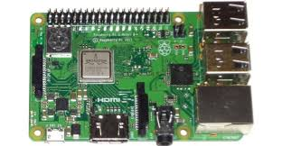

Figure5.1.1:-Raspberry - Pi

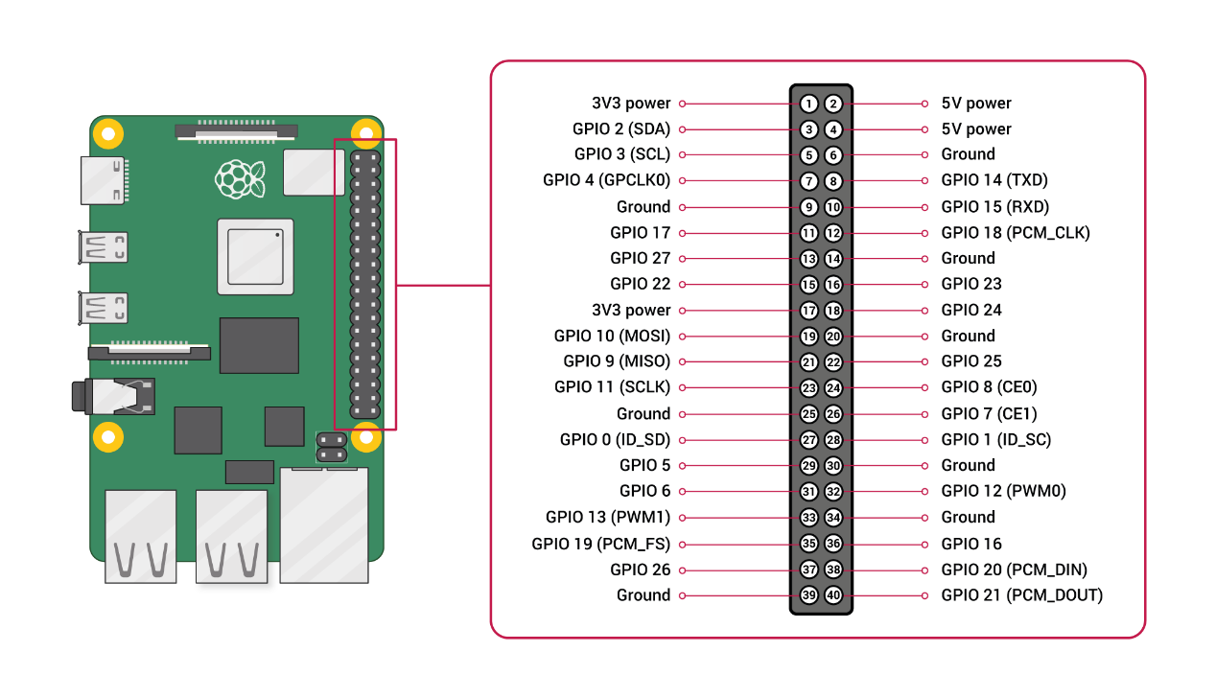

Fig 5.1.2:- Pin out of raspberry -pi

**5.2 Camera Module**

It is a low-cost Fisheye Lens, wider Field View, Camera module, designed for Raspberry Pi

* Raspberry Pi Camera, supports all revisions of the Pi
* Fisheye Lens, offers a wider field of view
* 5-megapixel OV5647 sensor
* Camera specifications

        CCD size: 1/4inch 6

        Aperture (F): 2.35

        Focal Length: adjustable

        Field of View: 160 degree (while other normal cameras are typically 72 degree)

        Diagonal angle: 160 degree

        Horizontal angle: 132 degree

         Sensor best resolution: 1080p

* 4 screw holes

        Used for attachment

        Provides 3.3V power output

        Supports connecting fill flash LED

* Dimension: 25mm x 24mm 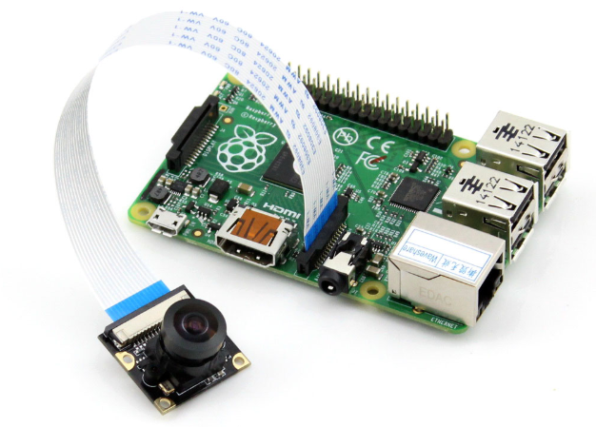

.

Figure 5.2:- Camera

**5.3 Servomotor**

The servo motor is most commonly used for high technology devices in industrial applications like automation technology. It is a self-contained electrical device, which rotates parts of the machine with high efficiency and great precision.

**Specification:**

**Tower Pro SG90**

* Size : 23x11x29 mm
* Voltage: 3V to 6V DC
* Weight: 9g / 0.32oz
* Speed : 0.12 sec/60 (at 4.8V)
* Torque : 1.6 kg-cm
* Working Temp: -30C~60C

Figure 5.3:- Servo Motor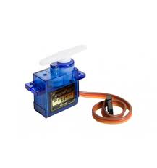

**5.4 DC Motor**

The **DC Motor**, is the most commonly used actuator for producing continuous movement and whose speed of rotation can easily be controlled, making them ideal for use in applications were speed control, servo type control, and/or positioning is required. A DC motor consists of two parts, a "Stator" which is the stationary part, and a "Rotor" which is the rotating part. The result is that there are basically three types of DC Motor available.

Specification

* Power = 12V
* RPM = 200 RPM

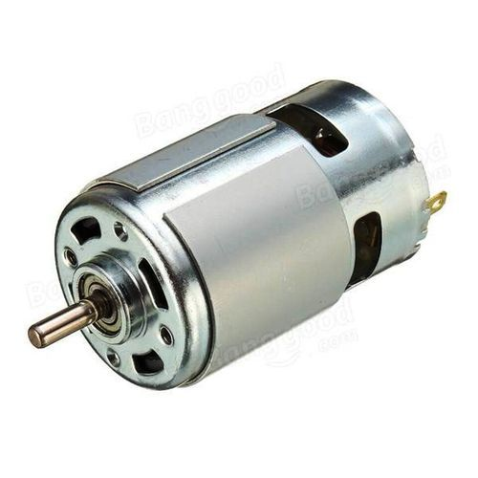

Figure 5.4:- DC Motor

**5.5 IR Sensor**

IR Sensor module has great adaptive capability of the ambient light, having a pair of infrared transmitter and the receiver tube. the infrared emitting tube to emit a certain frequency, encounters an obstacle detection direction (reflecting surface), infrared reflected back to the receiver tube receiving, after a comparator circuit processing, the green LED lights up, while the signal output will output digital signal (a low-level signal). The detection range of the sensor can be adjusted by the potentiometer, with little interference, easy to assemble, easy to use features, can be widely used robot obstacle avoidance, obstacle avoidance car assembly line count, and black-and-white line tracking and many other occasions.

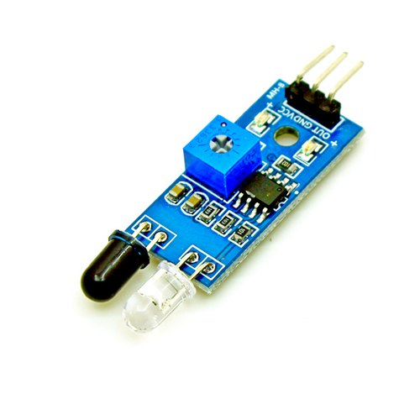

Figure 5.5:- IR sensor

Specification

* Operating Voltage:**3.0V – 5.0V**
* Detection range:**2cm – 30cm**
* Active output level: **Outputs Low logic level**
* **when obstacle is detected**
* Onboard Obstacle Detection LED

Indicator

**5.6 Power Supply.**

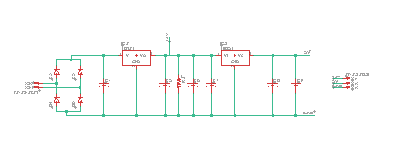

Fig 5.6 :- Circuit diagram of LRPS

The bridge rectifier is used. IC 7805 is used for output 5 V and IC 7812 for 12 V.

Capacitors are used.

**5.7 Mechanical Structure**

Specification of mechanical structure: - 100 cm X 30cm X 30cm

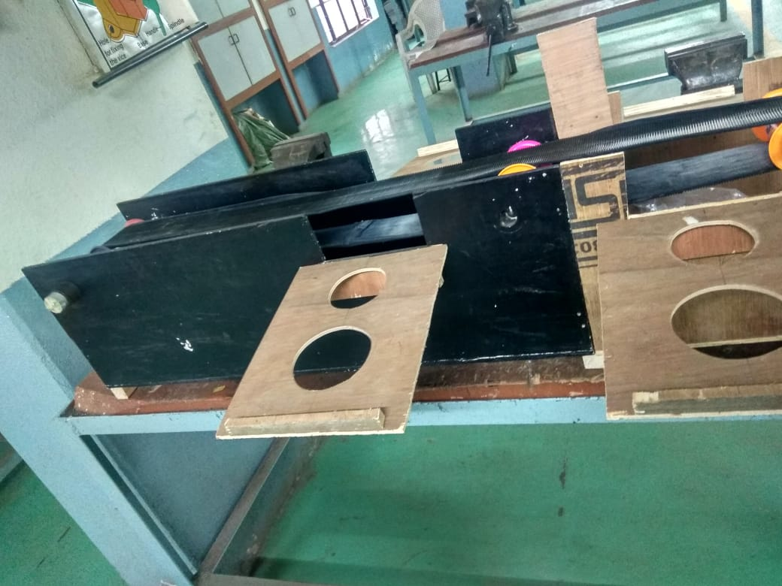

Figure 5.7:- Mechanical structure

1. **Software System Design :**

The software for the proposed system is based on image processing techniques. One of them is image segmentation, which makes a group of similar intensity pixel which separate the image into foreground and background. With the help of this, we make the region of interest. Edge detection is the type of discontinuity segmentation.

* 1. **Flowchart**

The system works according to the following flowchart.

IR initialized and detect obstacle and image capture by Pi-Camera

Image acquisition

Image segmentation

Training Set

Testing Set

Feature Extraction

Feature Extraction

Train KNN Classifier

Test

Output

Sorting with quality and size

Figure 6.1:- Flowchart.

Algorithm

1. The fruit will be kept on the conveyor belt, which is detected by the IR sensor and DC motor will stop. Servo will operate as a gate
2. The image will capture by pi-camera. This image is analyzed with different image processing techniques like edge detection, image segmentation, object recognition, etc.
3. After analysis, the gate will open and we come to know whether the fruit is an apple or an orange. Also, the quality is high or low.
4. After the analysis, the DC motor will start. According to this result, the servo motor will operate to slide the fruit to the respective side.
5. On both sides of the conveyor belt, circles are made with different diameters which will sort the fruit according to size.
6. This similar process will continue for the next fruit.

**6.2** **KNN Algorithm**

K Nearest Neighbors (KNN) is a very unassuming and multipurpose algorithm used in various applications like health care, image recognition, classification, and regression, etc. It is based on feature similarity approach for regression and classification problems. This model structure determined the dataset. All training data used in the testing phase. It required some time for scanning all data points. In KNN, K is the number of nearest neighbors. The number of neighbors is the core deciding factor. K is generally an odd number if the number of classes is 2. When K=1, then the algorithm is known as the nearest neighbor algorithm. This is the simplest case. Suppose P1 is the point, for which label needs to predict. First, find the k closest point to P1 and then classify points by majority vote of its k neighbors. Each object votes for their class and the class with the most votes is taken as the prediction. KNN has the basic steps which are to calculate distance, find closest neighbors, and vote for labels KNN performs better with a lower number of features than a large number of features. Figure am, and c shows the steps of the KNN algorithm.

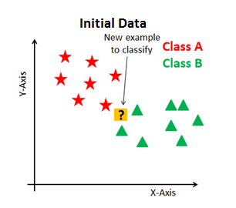 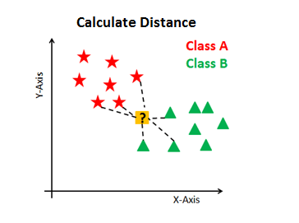 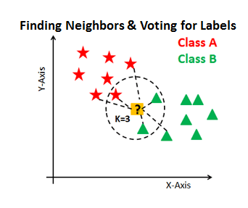

Figure a:-Initial Data. Figure b:-Calculate Distance. Figure c:- Finding Neighbors.

Figure 6.2:- KNN Algorithm.

* 1. **OPEN-CV Software**

OpenCV (Open Source Computer Vision Library) is an open-source computer vision and machine learning software library. OpenCV was built to provide a common infrastructure for computer vision applications and to accelerate the use of machine perception in the commercial products. Being a BSD-licensed product, OpenCV makes it easy for businesses to utilize and modify the code.



Figure 6.3:- Open CV Software.

1. **PCB Design**

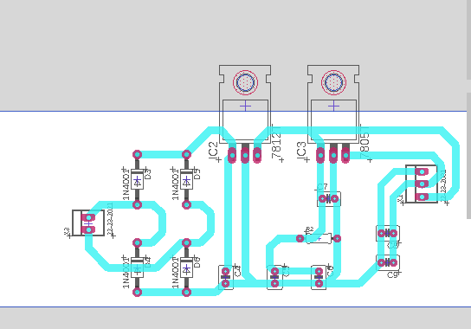

Fig 7.1:- PCB of LRPS

Software for PCB design: - EAGLE

**PCB Manufacturing Process Steps**

1. **Step** 1: **Design** and Output.
2. **Step** 2: From File to Film.
3. **Step** 3: Printing the Inner layers: Where Will the Copper Go?
4. **Step** 4: Removing the Unwanted Copper.
5. **Step** 5: Layer Alignment and Optical Inspection.
6. **Step** 6: Layer-up and Bond.
7. **Step** 7: Drill.
8. **Step** 8: Plating and Copper Deposition.

**8. Result**

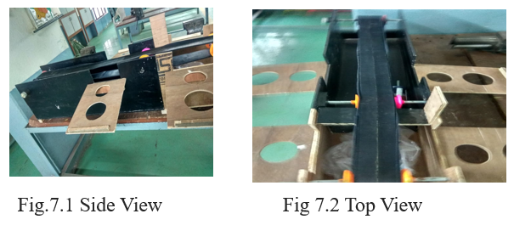

Figure 8.1:- Side View Figure 8.2:- Top View

With the hardware system, the fruit is sort according to size, as the servomotor slide the fruit with the respective side. The diameters for sorting of fruits are made 8cm and 15 cm respectively.

Software Result

For testing of images, we take a training dataset and testing dataset of 20 images of apple and orange.

The accuracy is measure by the algorithm is 90%.

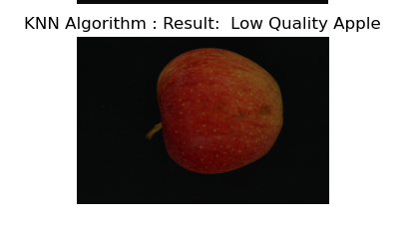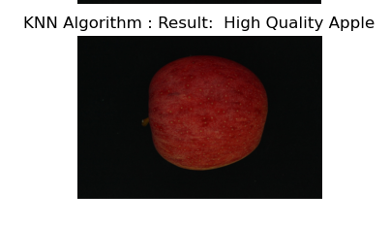

Figure 8.4:- Result of low-quality apple Figure 8.5:- Result of high-quality apple

1. **Applications & Future modifications**

* Proposed system we can use it in any industrial use where sorting on the basis of dimension is the main concern.
* Use for sorting of the desirable color of fruit and (e.g. raw and ripen fruit will be sorted)
* Can be used in food processing units like juice and jelly production units
* We can also use it for sorting of vegetables.
* Automated fruit sorting is speedy, inexpensive, safe, and accurate.

The system can be improved by making some changes in the program and components. Some suggestions are:

* Add a load cell for measurement and control of weight of the product
* A counter for counting the number of products
* Use of IoT system.

1. **Bill of material**

|  |  |  |  |
| --- | --- | --- | --- |
| **Sr. No** | **Item** | **Specification** | **Estimated Expenditure** |
|  | Raspberry –Pi | Model B | 2850 |
|  | Camera Module | 5 Mp | 490 |
|  | Conveyor Belt | 4cm X 100 Cm | 1200 |
|  | IR Sensor | - | 75 |
|  | DC Motor | 120 rpm | 1200 |
|  | Servo Motor | - | 450 |
|  | Transformer | 12V, 1 Amp | 300 |
|  | USB cable | _ | 150 |
|  | Enclosure Material |  | 400 |
|  | Solution | For Fixing the Belt | 80 |
|  | Heat Sink |  | 30 |
|  | Regulator IC | 7805,7812 | 20 |
|  | Contingencies |  | 560 |
| **Total =7805/-** | | | |

**11. Conclusion**

This paper proposes the mechanism to sort the fruit according to size and quality at a time. KNN algorithm is the active classification algorithm for automatic fruit sorting. The recognition of fruit is accurate up to 90%. The system having advantages of high accuracy and low cost. The proposed system reduces the errors to its minimum value and sorts the fruit based on two parameters. Some features we can implement with this system for fruit recognition and classification like counting the number of fruits, measuring the weight, and give the information of all this via IoT.

**12. References**

1. R. Swarna Lakshmi, B. Kanchanadevi 2014. “Review of fruit grading systems for quality inspection”. IJCSMC, Vol. 3, Issue 7, 615-621
2. Krithika Jayasankar, Karthika B, Jayashree T, Deepalakshmi R, Karthika G”Fruit Freshness detection using Raspberry Pi” International Journal of Pure and Applied mathematics Volume 119 No.15 2018, 1685-1691
3. Jyoti Jhawar “Orange Sorting by Applying Pattern Recognition on Colour Image” International Conference on Information Security and privacy(ICISP2015),11-12 December 2015, Nagpur, INDIA.
4. Güray Tonguc, Ali Kemal YAKUT“ Fruit Grading Using Image Processing Technique” article January 2009
5. Trupen Meruliya, Parth Dhameliya Image Processing for Fruit Shape and Texture Feature Extraction – Review International Journal of Computer Applications(0975-8887) Volume 129- No 8, November 2015.
6. Susovan Jana, Saikat Sasak, Ranjan Parekh “Automatic Fruit Recognition From Natural Images using Color and Texture feature” 2017 Device for Integrated Circuit(devIC) 23-24 March 2017 IEEE India.
7. Manali R. Satpute and Prof. Sumati M. Jagdale “Color, Size, Volume, Shape and Texture Feature Extraction Technique for Fruits – a review: IRJET Volume 3 issue 4 Apr 2016.
8. Woo Chaw Seng and Seyed Hadi Mirisaee. "A New Method for Fruit recognition System" 978-1-4224-4913-2 / 2009 IEEE
9. Seema, A. Kumar, and G.S. Gill. “Automatic fruit grading and classification system using computer vision – A review” 978-1-4799-1734-1/2015 IEEE
10. www.ieee.com